Egns

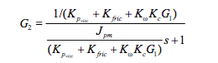

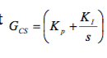

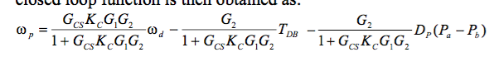

 where G1 can be 1/Rc = 2 and G2 = 0.83 (due to the electrical time constant being 100 times faster than the time constant of the hydraulic circuit.

Using the EHA prototype

The simplified transfer function for out system can theb e expressed as:

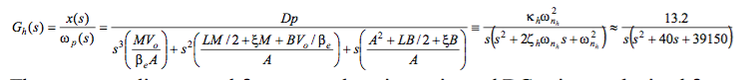

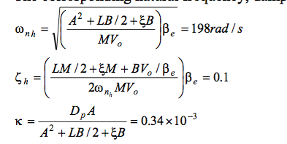

DC gain = -70

Resonant peak = 30HZ

SMC

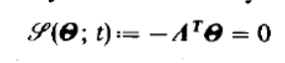

this is the observer poles and their gains. This is is the equation for switching hyperplane

[5] Arie Levant “Sliding order and sliding accuracy in sliding mode control”, *International Journal of Control*, 58(6), 1993, 1247-1263)

[6] G. Bartolini, A. Ferrara, A. Levant, E. Usai “On second order sliding mode controller” in Variable structure systems, sliding mode and nonlinear control, Springer Lecture Notes in Control and Information Sciences, Volume 247/1999.

where U is a positive constant to be taken sufficiently large. In practice, one has to progressively increase U until good performances are seen in the closed loop system. This kind of single-parameter “trial and error” tuning is particularly suited in practical implementation.